**Lab: DOM Events**

Problems with exercise and homework for the ["JS Front-End" Course @ SoftUni.](https://softuni.bg/modules/132)

**Environment Specifics**

Please, be aware that every JS environment may **behave differently** when executing code. Certain things that work in the browser are not supported in **Node.js**, which is the environment used by **Judge**.

The following actions are **NOT** supported:

* **.forEach()** with **NodeList** (returned by **querySelector()** and **querySelectorAll()**)
* **.forEach()** with **HTMLCollection** (returned by **getElementsByClassName()** and **element.children**)
* Using the **spread-operator** (**...**) to convert a **NodeList** into an array
* **append()** in Judge (use only **appendChild()**)
* **prepend()**
* **replaceWith()**
* **replaceAll()**
* **closest()**
* **replaceChildren()**
* Always turn the collection into a **JS array** (forEach, forOf, et.)

If you want to perform these operations, you may use **Array.from()** to first convert the collection into an array.

## List of Items

Write a function that **reads** the text inside an input field and **appends** the specified text to a list inside an HTML page.

### Examples

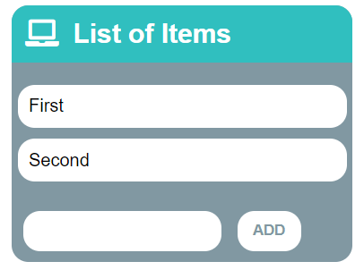🡪 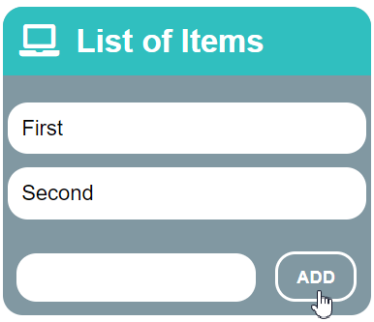🡪 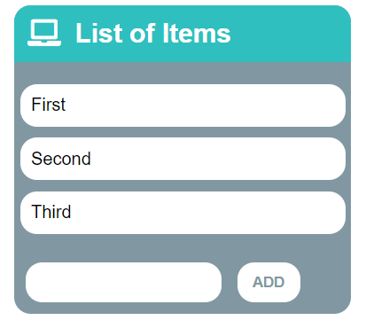

## Delete from Table

Write a program that **takes** an **email** from an **input field** and **deletes** the matching row from a table.

* If entry is found, the **textContent** in the element with **id="result**" must be set to **"Deleted."**
* Otherwise, an **error** should be displayed in a **<div>** with **id="result"**. The error should be **"Not found."**

Submit **only** the **deleteByEmail()** function in Judge.

### Input/Output

There will be no input/output, your program should instead **modify** the DOM of the given HTML document.

### Examples

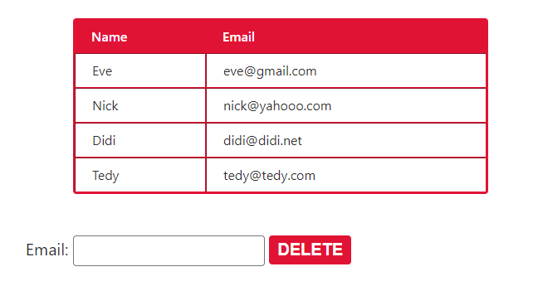

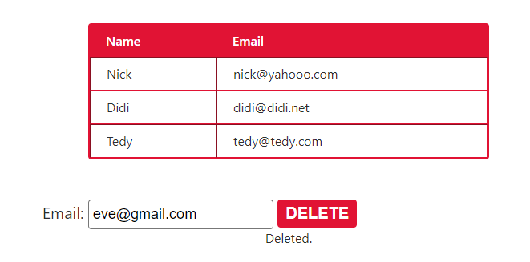

## Add / Delete

Extend the previous problem to display **a [Delete] link** after each list item. **Clicking** it should **delete** the item with no confirmation. You have to add **href="#"** to the link element.

### Examples

## Mouse Gradient

Write a program that **detects** and **displays** how far along a gradient the user has **moved** their **mouse**. The result should be **rounded down** and displayed as a **percentage** inside the **<div>** with id "**result**".

Submit **only** the **attachGradientEvents()** function in Judge.

### Input/Output

There will be no input/output, your program should instead **modify** the DOM of the given HTML document.

### Examples

Screenshot_2.png

## Highlight Active

Write a **function** that **highlights** the **currently active** section of a document. There will be **multiple** divs with **input fields** inside them. Set the **class** of the **div** that contains the **currently focused** input field to "**focused**". When the focus is lost (**blurred**), **remove the class** from the element.

Submit only the **focused()** function in Judge.

### Input/Output

There will be no input/output, your program should instead **modify** the DOM of the given HTML document.

### Example

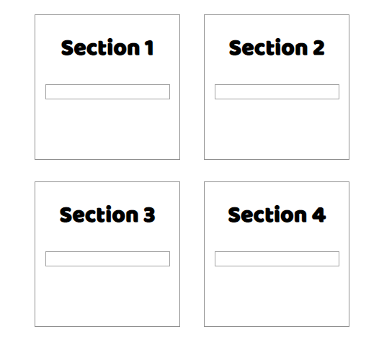 🡪 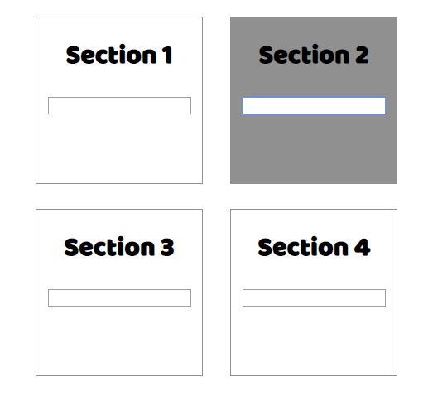

## Dynamic Validation

Write a **function** that **dynamically validates** an **email** input field when it is **changed**. If the input is **invalid**, apply the class "**error**". Do **not** validate on every keystroke, as it is annoying for the user, consider only **change** events.

A valid email is considered to be in the format: **<name>@<domain>.<extension>**

Only **lowercase Latin characters** are allowed for any of the parts of the email. If the input is valid, **clear** the style. Submit **only** the **validate()** function in Judge.

### Input/Output

There will be no input/output, your program should instead **modify** the DOM of the given HTML document.

### Example

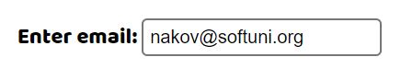🡪 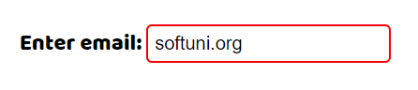

## Shopping Cart

You will be given some products that you should be able to add to your cart. Each product will have a name**,** picture,and price.

When the **"Add"** button is clicked, append the current product to the textarea in the following format: **"Added {name} for {money} to the cart.\n"**. The price must be fixed to the second digit.

When the button **"Checkout"** is clicked, calculate the **total money** that you need to pay for the products that are currently in your cart. Append the result to the textarea in the following format:

**"You bought {list} for {totalPrice}."**

The list should contain only the **unique products**, separated by **", "**. The total price should be rounded to the second decimal point.

Also, after clicking over "**Checkout**" and every from above is done you should **disable** **all** **buttons**. (You **can't** add products or checkout again if once the checkout button is clicked).

### Examples

